**CSE523** Machine Learning

Project: Shipment Price Prediction

Weekly Project Report: March 10, 2023

Team: **Revolution**

|  |  |
| --- | --- |
| Team Members | Enrolment-ID |
| Deep Patel | AU2040250 |
| Roshni Navdiya | AU2040114 |
| Aditya Padhariya | AU2040151 |
| Keval Parmar | AU1940133 |



* **Task Performed this week:**

1. Statistical analysis, both univariate and multivariate, can help generate even more information
2. Complete the features that will be used in the model training.
3. Get knowledge of the many categorization models that may be used with this particular data set.

* **Outcomes of the tasks performed:**

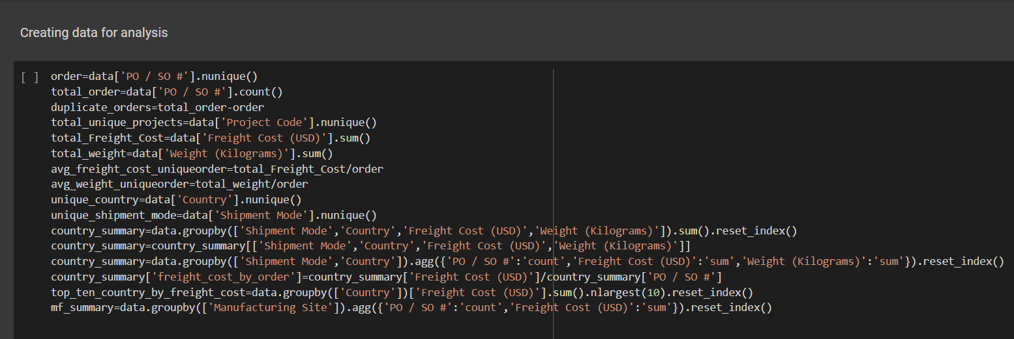

OUTPUT:

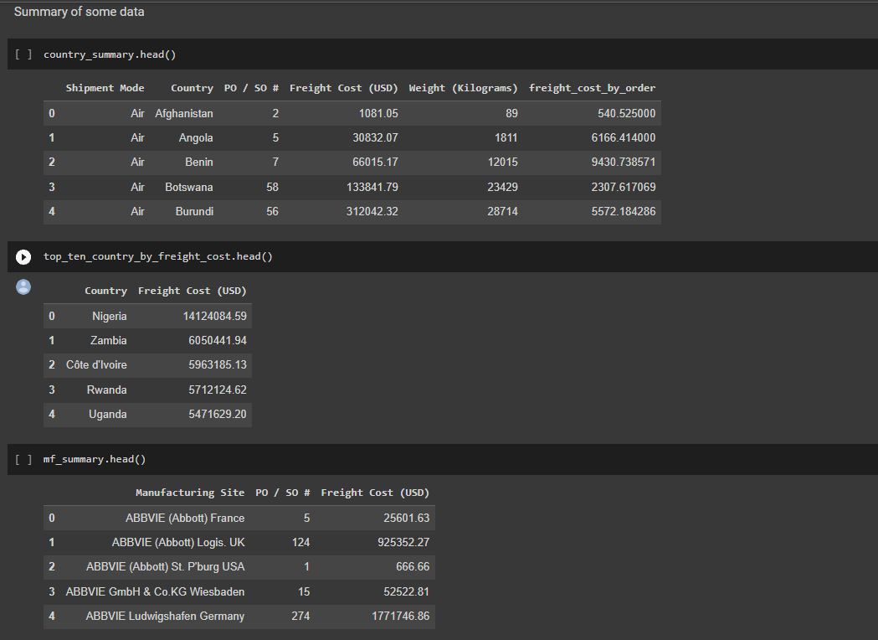

* **Tasks to be performed in the upcoming week:**

1. Start by putting the algorithm into operation.
2. Verify the model's accuracy and adjust the hyperparameters.